📂 Capstone Project

Capstone Project: Relational Database
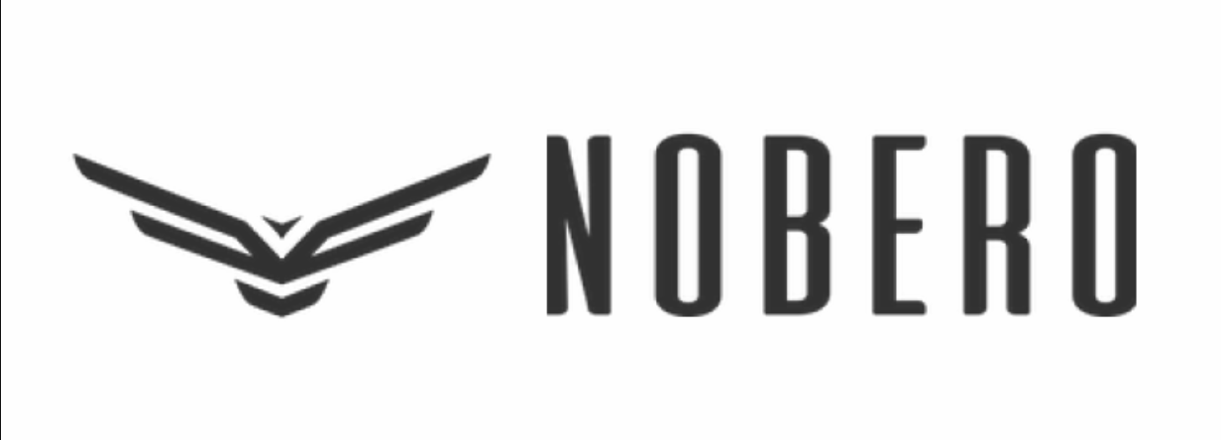

Product Dissection for Nobero

Platform Overview:
Nobero is a specialized Direct-to-Consumer (D2C) fashion leisure e-commerce platform offering a curated range of apparel for men and women. The platform emphasizes functional fashion, categorizing its products into lifestyle specific segments such as travel wear, co-ord sets, and oversized streetwear. By integrating a mobile application with a comprehensive web interface, Nobero provides a streamlined shopping experience that includes discovery, post purchase tracking, and educational content through fashion centric blogs.

Product Dissection & Key Features:
Nobero is a D2C fashion platform designed to simplify apparel discovery and purchasing in an otherwise fragmented online fashion landscape. The platform addresses the common challenge of overwhelming product choice by organizing its catalog into clearly defined apparel categories and curated collections aligned with user intent. Instead of relying on generic browsing, Nobero enables intent based discovery, allowing users to navigate directly toward use cases such as travel, premium everyday wear, or size inclusive fashion. This structured segmentation reduces cognitive load and shortens the decision-making process.
A key real world problem in digital fashion commerce is consumer trust, particularly around product quality and pricing authenticity. Nobero mitigates this by integrating social validation and pricing transparency directly into the product discovery layer. User ratings and review counts surfaced early, allowing customers to assess peer validated quality before engaging deeply with a product. The platform incorporates historical pricing indicators that communicate the lowest price offered in recent periods and the exact value of current discounts. This method reduces price mistrust and builds confidence in purchase decisions by addressing concerns around artificial discounting.
Nobero also tackles styling uncertainty, a frequent barrier in apparel purchases, by embedding editorial content into the shopping experience. Informational guides and trend based content function as decision aids, helping users evaluate fit, silhouette, and styling combinations. This bridges the gap between visual browsing and practical wardrobe needs, particularly for users who lack confidence in outfit coordination.

Case Study: Real-World Problems and Nobero's Innovative Solutions
Nobero, a prominent D2C brand, has addressed significant e-commerce challenges through its innovative features. By identifying specific consumer pain points and leveraging data driven design, Nobero has positioned itself as a solution oriented platform that simplifies the fashion journey and builds user trust.

Problem 1: Fit and Silhouette Uncertainty
Real-World Challenge: Consumers often find it difficult to determine which clothing fit such as regular versus oversized best suits their specific body type or style preference, leading to hesitation before purchasing.
Nobero's Solution: Nobero addresses this through an extensive library of educational content, including comparison guides like "Regular-fit vs. Oversized-fit T-shirts: Which Style Suits You Best?" and styling tips for plus-size men. By providing detailed size charts and content that explains the nuances of different fits such as "Heavyweight T-Shirts" versus "Drop Shoulder" styles the platform empowers users to make informed decisions tailored to their physique. This approach effectively reduces fit-related anxiety and enhances the overall shopping experience.

Problem 2: Price Integrity and Skepticism
Real-World Challenge: In a market saturated with "Sales", online shoppers are often skeptical of fluctuating discounts and lack confidence in whether a current price represents a genuine deal.
Nobero's Solution: Nobero solves this problem by integrating a "Lowest price in last 30 days" badge directly onto its product listings. The platform provides transparency by displaying the MRP, current sale price, and the specific "Amount OFF" (e.g., ₹1,500 OFF) for each item. This integrity gives users a clear understanding of the value they are receiving, mitigating price skepticism and giving immediate trust in the brand's pricing strategy.

Problem 3: Styling Complexity and Decision Fatigue
Real-World Challenge: Many individuals struggle to coordinate individual garments into cohesive outfits for specific occasions, such as travel or casual outings, leading to decision fatigue.
Nobero's Solution: The platform utilizes intent based collection segmentation, grouping products into specialized categories like "Travel Essentials" and "Co-ord Sets" to simplify the discovery process. Nobero acts as a virtual stylist through its "Explore Blogs" vertical, offering practical guides such as the "Black T shirt Matching Pants Guide: 7 Stylish Combos" and "How to Style Men’s Shorts". By providing pre matched sets and instructional content, Nobero removes the guesswork from fashion, allowing users to achieve a coordinated look with minimal effort.

Problem 4: Logistical Friction and Post Purchase Anxiety
Real-World Challenge: A lack of visibility into order status or a complicated return process can cause significant post purchase stress, deterring repeat customers.
Nobero's Solution: Nobero addresses logistical concerns through a centralized "Need Help" portal that offers streamlined self service features. Users have direct access to "Track Your Order" and a dedicated "Returns & Exchanges" system, ensuring transparency from checkout to delivery by providing a "Chat on WhatsApp" feature and accessible contact options, the platform ensures immediate support for any delivery hurdles, solving the problem of post purchase uncertainty and maintaining long term customer loyalty.

Conclusion
Nobero’s strategic evolution into a leading fashion destination is a testament to its ability to identify real world consumer problems and provide innovative solutions. By displaying price transparency, providing styling education, simplifying lifestyle discovery, and ensuring logistical clarity, Nobero has addressed the various challenges that users encounter in the D2C e-commerce landscape. This case study showcases how a user centric approach and continuous focus on features position Nobero as a leader in its domain, effectively shaping a more confident and effortless shopping experience for its global user base.

Top Features List
User Accounts: Nobero allows users to create personalized profiles through the "My Account" portal to manage their entire shopping journey. This feature provides a dedicated space for customers to track their "Cashback & Rewards," reflecting an individual and incentivized online presence.
Social Proof: Validation is central to the interface, featuring "Bestseller" tags and aggregated star ratings like "4.9 | 1K" on top selling styles. Users can share their experiences through a dedicated "Reviews" section, helping others navigate popular items with peer validated confidence.
Price Transparency: A unique feature is the "Lowest price in last 30 days" badge, which provides integrity for every discount offered. By explicitly showing the "Amount OFF" from the original MRP, the platform ensures users are fully informed about the current deal's value.
Explore Blogs: The "Explore Blogs" vertical propels discovery by offering trend reports and styling guides like the "Black T shirt Matching Pants Guide". Users can explore celebrity inspired looks, such as "Airport Goals" featuring Alia Bhatt, fostering a diverse and educational fashion experience.

Schema Description
The following schema architecture is designed to reflect the data requirements of a high growth D2C fashion platform.
User Entity
Users represent customers who browse, purchase, and interact with products on the Nobero platform. This entity stores essential account and contact information required for authentication, order processing, and communication.
- UserID (Primary Key): Unique identifier for each user
- Name: Full name of the user
- Email: Email address used for login and order communication
- Phone: Contact number for delivery updates and support
- Registration_Date: Date when the user registered on the Nobero website

Product Entity
Products represent the core merchandise sold by Nobero. This entity captures product level information that remains consistent across variants.
- ProductID (Primary Key): Unique identifier for each product
- CategoryID (Foreign Key): Category to which the product belongs
- Name: Product name as displayed on the website
- Description: Detailed description of the product
- MRP: Maximum retail price of the product
- Current_Price: Selling price after discounts
- Lowest_Price_30_Days: Lowest price offered in the last 30 days for compliance and transparency
- Is_Bestseller: Indicates whether the product is marked as a bestseller

Variant Entity
Variants represent purchasable combinations of a product based on size and color. Inventory is tracked at the variant level.
- VariantID (Primary Key): Unique identifier for each product variant
- ProductID (Foreign Key): Associated product
- Size: Available size (S, M, L, XL, Plus)
- Color: Color of the variant
- SKU: Stock keeping unit for internal tracking
- Stock_Level: Available inventory count for the variant

Cart Entity
The cart temporarily stores items selected by a user before checkout.
- CartID (Primary Key): Unique identifier for the cart
- UserID (Foreign Key): User who owns the cart
- Total_Amount: Total value of items currently in the cart
- Last_Updated: Timestamp of the last cart modification

Order Entity
Orders represent confirmed purchases made by users after checkout.
- OrderID (Primary Key): Unique identifier for each order
- UserID (Foreign Key): User who placed the order
- Order_Date: Date and time when the order was placed
- Total_Paid: Final amount paid after discounts and offers
- Status: Current order state (Placed, Shipped, Delivered)

Payment Entity
Payments store transaction details related to orders.
- PaymentID (Primary Key): Unique identifier for each payment
- OrderID (Foreign Key): Associated order
- Payment_Mode: Method used for payment (UPI, COD, Card)
- Transaction_Status: Status of the transaction (Success, Failed, Pending)

Delivery Entity
Delivery tracks shipment and logistics information for orders.
- DeliveryID (Primary Key): Unique identifier for delivery record
- OrderID (Foreign Key): Associated order
- Tracking_Number: Courier tracking reference
- Carrier_Name: Logistics partner handling the delivery
- Est_Arrival: Estimated delivery date

Review Entity
Reviews capture customer feedback and ratings for products.
- ReviewID (Primary Key): Unique identifier for each review
- ProductID (Foreign Key): Reviewed product
- UserID (Foreign Key): User who submitted the review
- Rating: Product rating (typically 1–5)
- Comment_Text: Optional textual feedback
Offer Entity
Offers represent promotional discounts available to users.
- OfferID (Primary Key): Unique identifier for each offer
- Coupon_Code: Redeemable coupon code
- Discount_Value: Discount amount or percentage
- Expiry_Date: Validity end date of the offer

Relationships
- Users place Orders: Each user can place multiple orders, and each order is placed by a single user.
- Users maintain Carts: Each user can have one active cart, and each cart belongs to exactly one user.
- Users make Payments for Orders: Users can make multiple payments across different orders, and each payment is linked to a single order.
- Orders have Payments: Each order is associated with one or more payment attempts, and each payment corresponds to one order.
- Orders have Deliveries: Each order has one delivery record, and each delivery corresponds to one order.
- Users write Reviews for Products: Users can write multiple reviews, and each review is written by one user for one product.
- Products receive Reviews: Each product can have multiple reviews, and each review is associated with a single product.
- Products have Variants: Each product can have multiple variants, and each variant belongs to exactly one product.
- Users add Products to Carts: Users can add multiple product variants to their cart, and each cart can contain multiple product variants.
- Orders contain Product Variants: Each order can contain multiple product variants, and each variant can appear in multiple orders over time.
- Offers apply to Orders: An offer can be applied to multiple orders, and each order may have zero or one offer applied.

ER Diagram
I constructed an ER diagram that widely portrays the relationships and attributes of the entities within the Nobero schema. This ER diagram will serve as a visual representation, focusing on the pivotal components of Nobero's data model, such as its categories, historical pricing attributes, and blog integration. I have created two ER diagrams, one with PostgreSQL in Chen Notation and another with an online tool dbdiagram in Crow foot Notation.
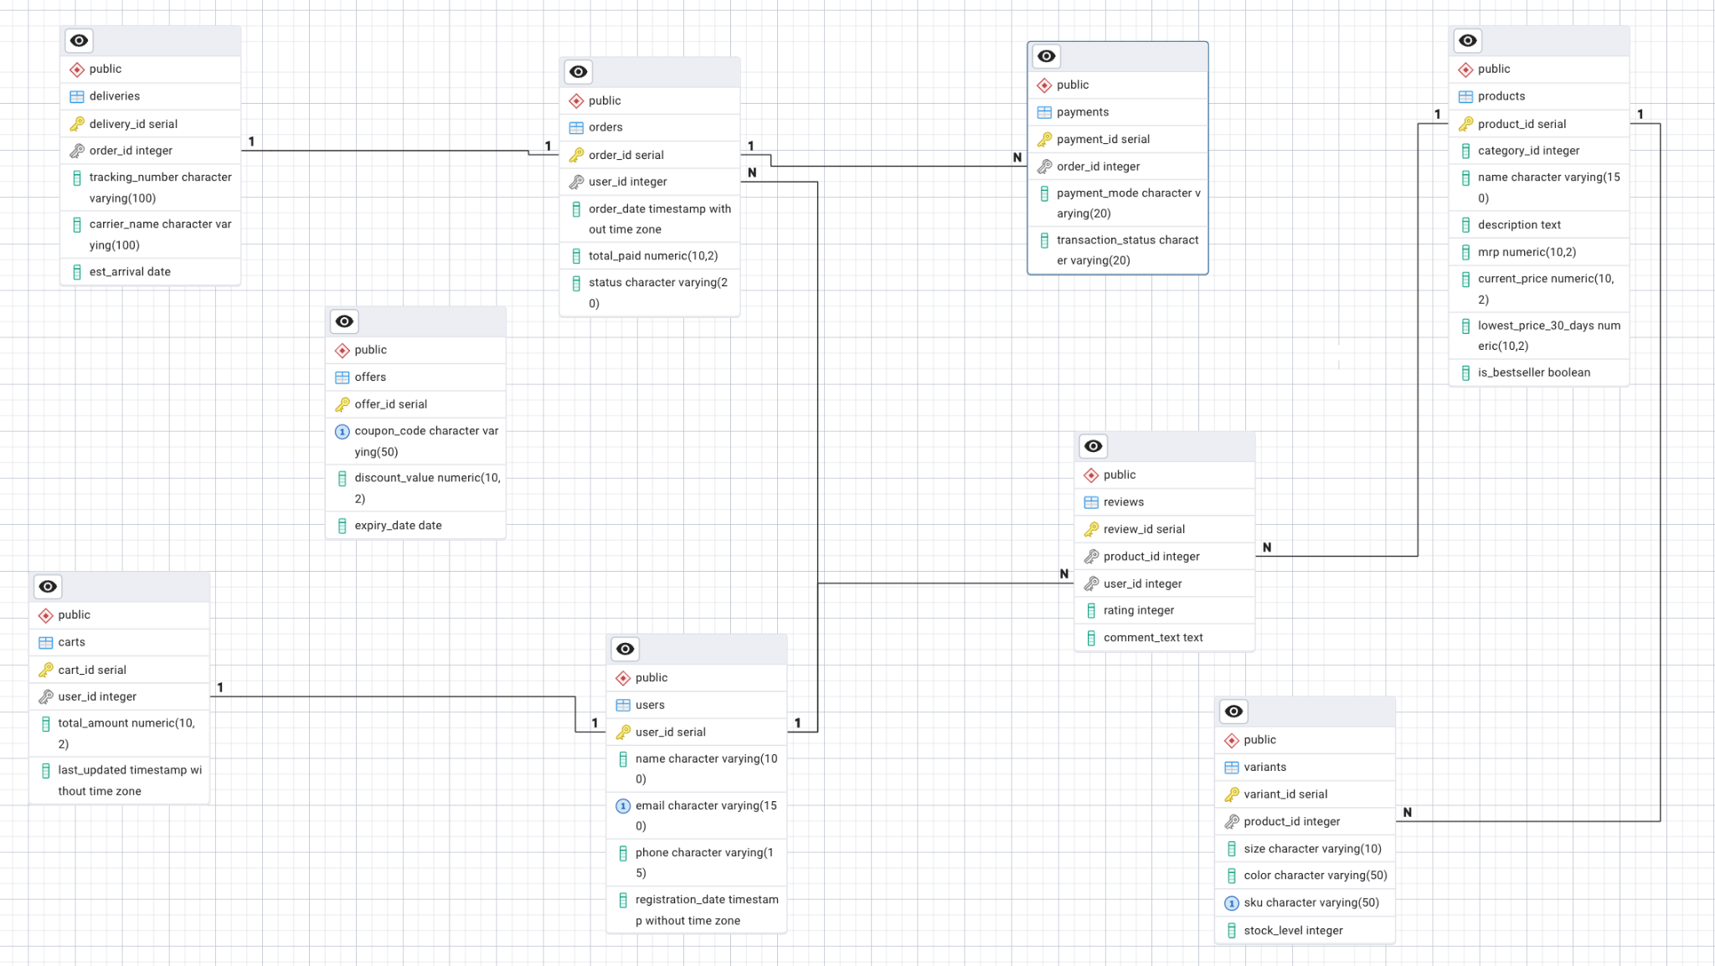
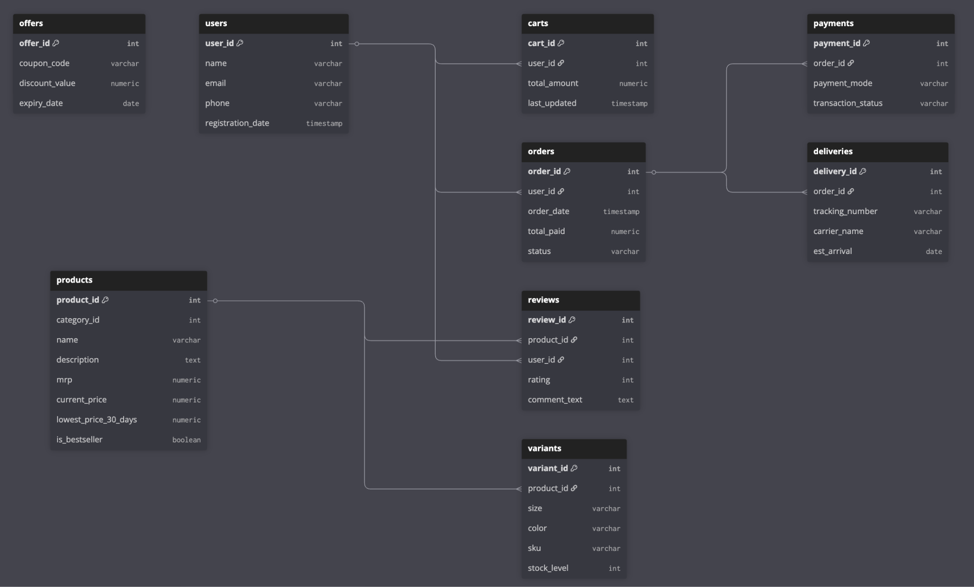

Conclusion
Nobero's strategic alignment of user centric features with a strong, scalable data architecture is the key to its success as a top D2C fashion platform. Nobero implements creative solutions, such as carefully chosen lifestyle collections, historical price transparency, and numerous educational content, to address practical issues including styling weariness, fit uncertainty, and price skepticism. This product dissection shows that the platform's operational efficacy and long term user engagement are critically dependent on a well structured schema that prioritizes variant level inventories and integrated post purchase lifecycle management. Nobero's seamless integration of fulfillment, validation, and discovery technologies serves as an example of how careful design may address challenging customer problems in the contemporary e-commerce market.

VIDEO PRESENTATION LINK: Presentation Link

